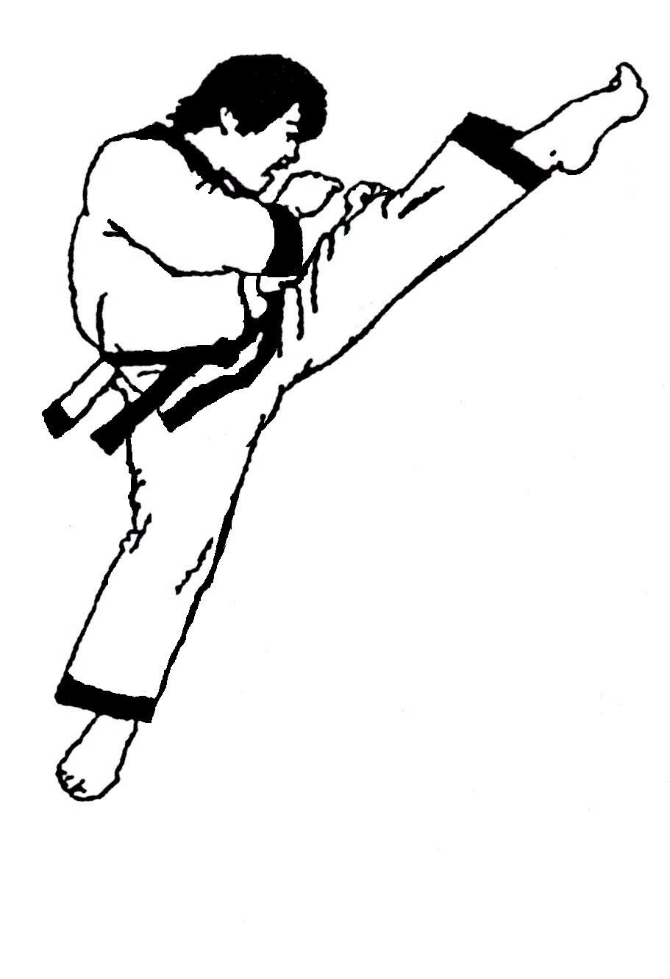 MOUNTAIN KIM MARTIAL ARTS 65th TOURNAMENT

November 12th, 2022

|  |  |  |
| --- | --- | --- |
| **Pre-registration** | One-Event | $85 |
| Two-Events | $95 |
| Three-Events | $105 |
| **At the door** | One-Event | $105 |
| Two-Events | $115 |
| Three-Events | $125 |

|  |  |  |  |  |  |  |  |  |
| --- | --- | --- | --- | --- | --- | --- | --- | --- |
| Name | | |  | | | | | |
| Phone | | | |  | | | | |
| Address | | | | |  | | | |
| City |  | | | | | | | |
| State | |  | | | | | Zip |  |
| Emergency Contact & Phone # | | | | | | |  | |
| Email | |  | | | | | | |
| Do Jang (school location) | | | | | |  | | |

**Spectator:** $10.00 (Free for 5 under, and 65 above)

**All fees are NON-REFUNDABLE**

|  |  |  |  |  |  |  |  |  |  |  |
| --- | --- | --- | --- | --- | --- | --- | --- | --- | --- | --- |
| **BELT COLOR:** | | | | | | | | | | |
| **PLEASE CIRCLE EACH CATEGORY** | | | | | | | | | | |
| **BELT GROUP** | | | | | | | | | | |
| **Black** | | **Gold Stripe and under** | | | | **Green and above** | | | | |
| 9:00 AM | | 10:00 AM to 12:30 PM | | | | 1:00 PM to 5:30 PM | | | | |
|  | |  | |  | | |  | | |  |
| **EVENT:** | | Forms  Judo | Breaking  Gumdo | | | Sparring  Weapon | | | *(Judo, Gumdo & Weapon at 10:00am)* | | |  |
|  | |  | |  | | |  | | |  |
| **DIVISION:** | | Men/Boys | | | | Women/Girls | | | | |
|  | |  | | | | |  | | | |
| **AGE GROUP & RING ASSIGNMENT** | | | | | | | | | | |
| **Ring # 1** | **Ring # 2** | | | | **Ring # 3** | | | **Ring # 4** | | |
| 3 / 4 / 5 | 6 | | | | 7 | | | 8 | | |
| **Ring # 5** | **Ring # 6** | | | | **Ring # 7** | | | **Ring # 8** | | |
| 9 & 10 | 11 & 12 | | | | 13 &14  15 & up | | | Weapon & Judo | | |

**NOTE**: Depending on number of participants, age groups and/or belt levels may be combined for form and board breaking. Sparring will not be combined in any level.

|  |
| --- |
| **Black Belt Meeting**: 8:30 AM, All black belts (referees, judges, competitors) are expected to attend this meeting. |

|  |
| --- |
| **RULES** |

1. **Form**: If a competitor performs a form that is lower belt than the competitor’s own, the competitor will get disadvantage. If WTF form is not performed, the competitor will get disadvantage.

2. **Sparring**: All competitors are expected to bring their sparring equipment: Mouth Guard, Groin Cup, Head Gear, Instep & Shin Guard, Hand & Forearm Guard, Chest Protector.* All required sparring gear and boards will be sold at the championship entrance.

* Traditional World Tae Kwon Do Federation rule (modified by Mountain Kim Martial Arts). Two points for controlled head kick. One point for chest guard strike with kick or noticeable reverse punch.
* One round of 90 seconds for all color belts. Two rounds of 60 seconds for black belts

3. **Board Breaking**:

* All color belts – Maximum 3 targets.
* Black Belts – Maximum 5 targets.

|  |
| --- |
| **WHITE UNIFORMS ONLY** |

*NO SAND BLOCKS OR BRICKS. WOODEN BOARDS ONLY

I hereby submit my application for registration in the 2022 Mountain Kim Martial Arts 65th championship. I agree to waive all claims against anyone associated with the championship for injuries I may sustain, and likewise will assume full responsibility for all my actions in connection with the Championship.

I shall strictly observe and obey the rules and regulations, printed, verbal or otherwise, governing this Championship. I further agree that any picture taken of me in connection with the Championship can be used by Championship Director for publicity or promotion without compensation at this or any other time.

|  |  |
| --- | --- |
| Signature | Date |
| PARENT OR GUARDIAN (IF UNDER 18 YEARS OF AGE) | |

**SEND PAYMENT TO**: Mt.Kim

P.O. Box 7

Clifton, VA 20124

**PLACE OF TOURNAMENT:**

**Northern Virginia Community College**

Annandale Campus - Ernest Cultural Center

8333 Little River Turnpike, Annandale, VA 22003

Parking is available in “Lot B”

For information: (703)-255-0202 or email [info@mtkim.com](mailto:info@mtkim.com); for general information email mtkimvienna@gmail.com